**JAVASCRIPT Activity – Royal GYM**

**RoyalGym.html** and incomplete **gym.js** files have been provided with this activity. The html file shows following form in the browser.

You need to write add code to the given external **JavaScript** file that implements the following requirements.

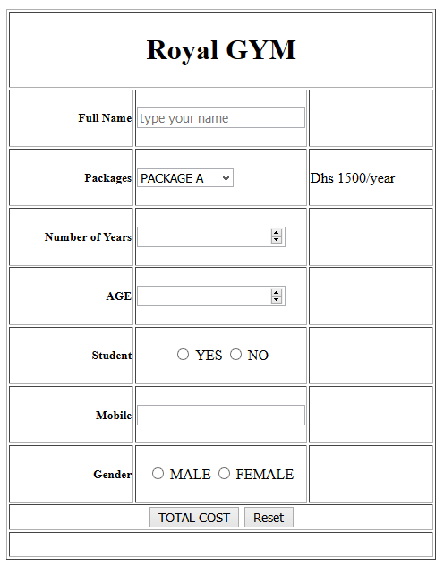

**Application Requirements:**

Add missing code in the functions in gym.js to fulfil the requirements.

**Royal Gym offers the following packages:**

PACKAGE A – Dhs 1500 per year

PACKAGE B – Dhs 2000 per year

PACKAGE C – Dhs 2500 per year

PACKAGE D – Dhs 3000 per year

PACKAGE VIP – Dhs 5000 per year

**Data Validation rules:**

Name should be at least 8 letters long, spaces are allowed.

Phone number should be valid UAE mobile number. TODO

Years should be in range 1-5. TODO

Age should be in range 18-65.

Gender must be selected.

**Student must be selected. TODO**

**Total Cost Calculation:**

**Total amount = package cost * years**

If the age is above 60, a discount of 30% of the total amount is offered.

**Final amount = total amount – age discount**

If the gender is female an additional discount of 5% of the total amount is offered.

A student is offered an additional discount of 10% of the total amount.

**Final amount = ?**

**YOUR TASKS:**

Modify code in **gym.js** code to implement the remaining requirements.

* Add/Modify function **packagePrice( )** for missing packages
* Add new function **validate( )** 
  + Perform input data validation according to given rules
  + print appropriate data validation messages in the adjacent area.
* Add/Modify code in function **finalAmount ( )**
  + Total cost should be calculated if all the entered data is valid
  + Total cost should include all discounts